The NR-XIII

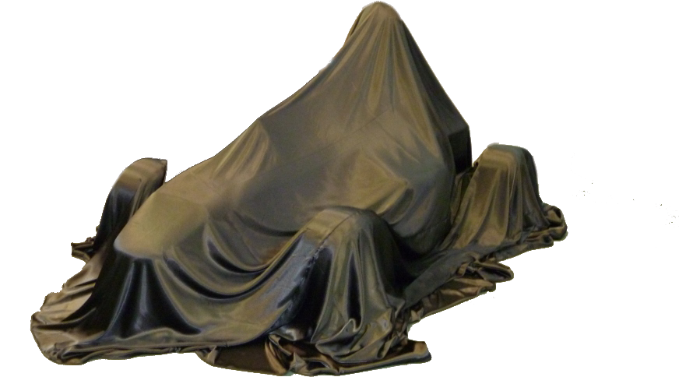

*The DH NR-XIII*

Efforts toward the DH NR-XIII, our car for the next season are in full swing. We concluded the design process in January 2013. Key additions this year include:

1. Center feed intake system made of carbon-fibre
2. Steering-mounted completely clutch-less electronic gear shifters for 75% faster gear changes
3. Lower drive ratio for faster acceleration
4. Pushrod suspension for improved packaging
5. Hand actuated clutch for improved pedal assembly
6. Use of rapid-prototyping process for manufacturing intake system components
7. Targeted weight of 220kilograms
8. Multi-function displays on the steering wheel and dash-board.

For further updates on the manufacturing progress, please check the *Updates* and *Gallery*.